**Q1. Write an SQL query to delete all records from the student table where the city is 'Chicago'.**

**Query –**

* CREATE TABLE student (

name VARCHAR(50),

roll_no INT PRIMARY KEY,

city VARCHAR(50),

phone_number VARCHAR(15)

);

* INSERT INTO student (name, roll_no, city, phone_number) VALUES

('Alice Smith', 1, 'New York', '123-456-7890'),

('Bob Johnson', 2, 'Los Angeles', '234-567-8901'),

('Charlie Brown', 3, 'Chicago', '345-678-9012'),

('David Williams', 4, 'Houston', '456-789-0123'),

('Eva Davis', 5, 'Phoenix', '567-890-1234'),

('Frank Miller', 6, 'Philadelphia', '678-901-2345'),

('Grace Wilson', 7, 'San Antonio', '789-012-3456'),

('Hannah Moore', 8, 'San Diego', '890-123-4567'),

('Ivy Taylor', 9, 'Dallas', '901-234-5678'),

('Jack White', 10, 'San Jose', '012-345-6789');

* Select * from student;
* DELETE FROM student

WHERE city = 'Chicago';

* Select * from student;

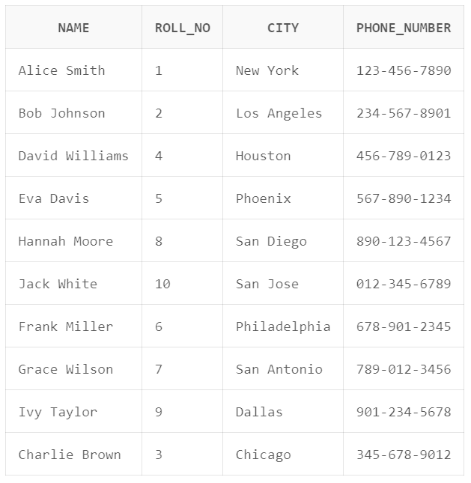**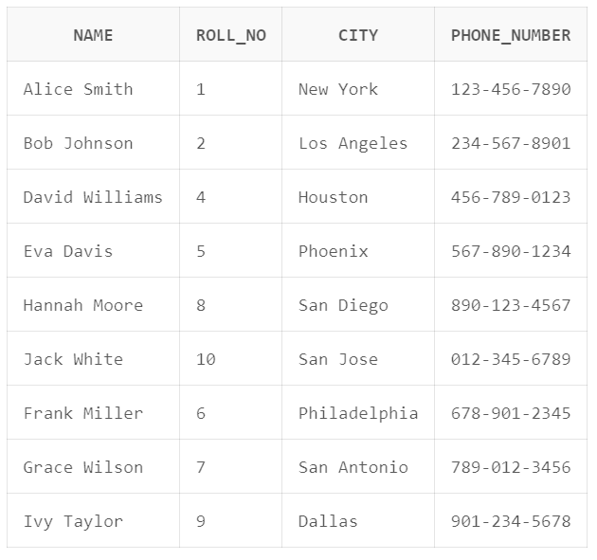OUTPUT**

**After**

**Before**

**Q2.** **Write an SQL query to retrieve all columns from the student table and display the records in descending order based on the roll_no.**

**Query-**

INSERT INTO student VALUES('bruce Smith', 11, 'New York', '123-456-7234')

SELECT * FROM student

ORDER BY roll_no DESC;

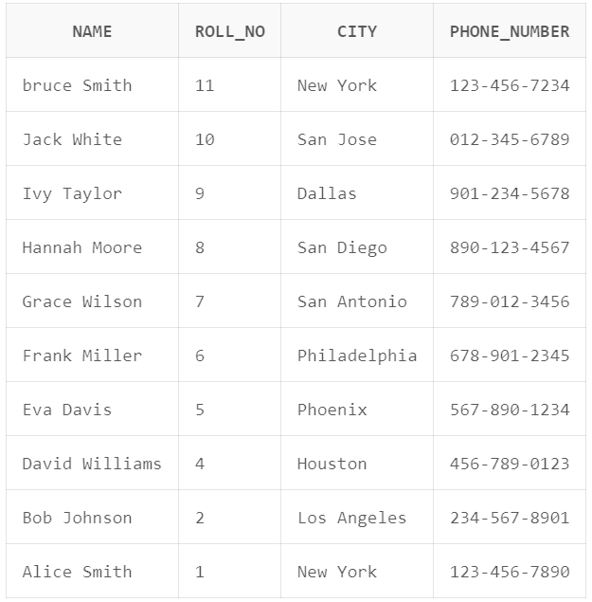**OUTPUT**